**Supplementary Material**

**Peptide-based direct electrochemical detection of receptor binding domains of SARS-CoV-2 spike protein in pristine samples**

T. H. Vignesh Kumara,1, Sowmiya Srinivasanb,2, Vinoth Krishnana,c,2, Rama Vaidyanathanb,d,

Kannadasan Anand Babub,*, Sudhakar Natarajane,*, Murugan Veerapandiana,c,*

aElectrodics and Electrocatalysis Division, CSIR-Central Electrochemical Research Institute (CECRI), Karaikudi-630 003, Tamil Nadu, India.

bDr. A.P.J. Abdul Kalam Center of Excellence in Innovation and Entrepreneurship, Dr. M.G.R Educational and Research Institute Chennai-600 095, Tamil Nadu, India.

cAcademy of Scientific and Innovative Research (AcSIR), Ghaziabad-201 002, India

dDepartment of Biotechnology, Dr. M.G.R Educational and Research Institute Chennai-600 095, Tamil Nadu, India.

eDepartment of Virology and Biotechnology, ICMR-National Institute for Research in Tuberculosis, Chennai-600 031, Tamil Nadu, India.

1Present address: Electrical and Computer Engineering, Iowa State University, Ames, Iowa 50011, United States America.

Corresponding authors:

E-mail addresses

M. Veerapandian: [vmurugan@cecri.res.in](mailto:vmurugan@cecri.res.in)

K. Anand Babu: [kabpharm@gmail.com](mailto:kabpharm@gmail.com)

S. Natarajan: [sudhakar.na@icmr.gov.in](mailto:sudhakar.na@icmr.gov.in)

*2Equally contributed*

1. **Experimental Section**
   1. **Chemicals and Reagents**

Methylene blue hydrate, a high purity biological stain with a purity of 96+ percent, was purchased in New Jersey (USA). Sigma-Aldrich Chemicals Private Limited provided GO powder (15-20 sheets, 4-10 percent edge-oxidized), bovine serum albumin (BSA), AnteoBindTM, human serum albumin (HSA), and immunoglobulin-G (IgG) (USA). BSA and IgG were kept at -20°C for future usage, while HSA was kept at 4°C. Panbio diagnostics provided the dengue NS1 antigen, which was kept at 4 degrees Celsius. AsianBioChem (India) provided the custom-designed N-terminal *h*ACE-2 peptide, which was kept at room temperature.

Cusabio Technology LLC (China) provided partial recombinant human novel coronavirus spike glycoprotein (S), which was kept at -20 ºC. The remainder of the chemicals were similarly purchased in analytical grade and utilised without additional purification. Phosphate buffer solution (PBS) was prepared by using disodium hydrogen phosphate dihydrate (Na2HPO4.2H2O) and sodium dihydrogen phosphate dihydrate (NaH2PO4.2H2O). All the experiments were carried out at a constant room temperature of 29 ºC unless otherwise specified. Milli-Q water was used to make the 100 μg/mL S protein stock solution, and additional dilutions were made with 0.1 M PBS in 7.4 pH. Followed by, we added 50% of glycerol in S protein aliquot for long-term storage at -20 ºC. Milli-Q water was used to make the 0.1 mg/mL IgG, 1 mg/mL HSA, 1 mg/mL NS1, and 1 mg/mL N-terminal *h*ACE-2 peptide stock solutions, and additional dilutions were made with 0.1 M PBS (pH 7.4). Milli-Q water (>18.2 MΩ cm, Merck Millipore) was used to make all of the aqueous solutions.

* 1. **Instrumentation**

The UV-visible absorbance spectra of MB, GO, and MB-GO were measured with a Varian Cary 5000 spectrometer, USA. A Raman spectrometer (LabRam HR evolution, Horiba) was used to characterize GO, MB and MB-GO. Typically, 532 nm laser excitations were used for Raman spectral analysis in the region 1000 to 3500 cm-1. A field-emission scanning electron microscope was used to examine the surface morphology of GO and MB-GO (FE-SEM; model: Carl Zeiss, SUPRA 55VP). CHI-1000A from CH Instruments, Inc. Austin, USA, was utilized for Cyclic voltammetry studies. Rodeostat Plus: multichannel potentiostat (IO Rodeo, Inc. Pasadena, USA) was used to perform chronoamperometry (CA) studies. Potential region opted for CV studies are 0.8 to 0.2 V. Throughout the CV studies phosphate buffered saline (PBS, 0.1 M) of pH 7.4 was used as supporting electrolyte. Except scan rate study all the CV response from the peptide sensor platform was performed at a scan rate of 50 mV/s. CA studies were performed at an applied bias potential of 0.48 V. Electrolyte used for preparing target SP for standard studies and spiked analysis was PBS 0.1 M (pH 7.4).

* 1. **Preparation of the MB-GO dispersed solution**

Graphene oxide (GO) was dispersed into aqueous solutions of methylene blue (MB) at various concentrations (0.016 mg/mL (GO) in 0.1 mM (MB), 0.08 mg/mL (GO) in 0.5 mM (MB), 0.16 mg/mL (GO) in 1 mM (MB), 0.25 mg/mL (GO) in 1 mM (MB), 0.5 mg/mL (GO) in 2 mM (MB). Following that, these solutions were probe-sonicated (Hielscher UP200 Ht) for 1 hour (3 sec ON/2 sec OFF) at 50% amplitude using a horn type probe (Titanium alloy, 7 mm diameter) (**Fig. S1**). The resultant dispersion was centrifuged at 3000 rpm (Hettich Universal 320R) for 10 minutes to precipitate the bundles and impurities after probe sonication. Then, using a syringe, the supernatant of the dispersed MB-GO solution was collected to remove the bundles and impurities. Finally, the collected dispersed MB-GO solution was used to modify the electrodes (**Scheme S1**).

**1.4. Molecular docking of SARS CoV-2 spike protein and Lactoferrin with *h*ACE-2 receptor**

Molecular docking was employed to identify the short peptide sequence (N-terminal and C-terminal) of *h*ACE-2 with high binding affinity to SARS CoV-2 spike protein (PDB id: 6VYB) and perform a comparative evaluation of binding affinity of mutant strains of SARS CoV-2 spike protein with the high binding affinity peptide. The mutated spike proteins were created by mutating the SARS CoV-2 spike protein using PyMOL and three mutated spike protein structure retrieved from RCSB (G614- PDB id: 7KDL, B.1.1.7- PDB id: 7LWS, B.1.1.28- PDB id: 7LWW). Lactoferrin, the most abundant protein in nasopharyngeal sample was docked with *h*ACE-2 receptor to check the cross reactivity[1]. The docking was performed using ADFRsuite 1.0 developed for protein-peptide docking. The peptide and spike protein interaction were studied using DimPlot and visualised using PyMOL.

**1.5. Determination of secondary structure of peptides using CD spectroscopy and in silico approach**

Circular Dichroism (CD) spectra of N-terminal and C-terminal peptides were recorded on a Jasco J-815. CD spectra were recorded in solvent buffer in 10 mm quartz cell between 250 to 190nm. The secondary structure content was calculated using BeStSel server. The secondary structure of the peptides was predicted using PEP-FOLD3.5 server.

**1.6. Collection of gargled-lavage samples**

Gargled lavage fluids from two healthy volunteers were collected and stored at ₋20 ºC until they were needed for analysis. Volunteers are recommended to avoid meals and coffee before 60 minutes and rinse mouth with water prior to sample collection [2]. Sampling was collected at CSIR-CECRI following institutional ethical and healthcare/safety committee guidelines.

**1.7. Preparation of clinical swab samples**

Nasopharyngeal and oropharyngeal swab specimens collected in viral transport medium were received from Greater Chennai Corporation for COVID testing at ICMR - National Institute for Research in Tuberculosis (NIRT), Chennai. Those swab specimens were aliquoted and preserved at -80°C. The study was approved by the Institutional Ethics Committee of ICMR – National Institute for Research in Tuberculosis (NIRT), Chennai [NIRT IEC No: 2020 042].

**1.8. Viral RNA extraction and molecular testing of SARS CoV-2 infection in COVID-19 samples using RT-PCR**

Extraction of viral RNA from 200μL of oropharyngeal and nasopharyngeal swab samples collected in viral transport medium (VTM) was performed using MGIEasy Magnetic beads Virus DNA/RNA extraction kit (MGI Tech Co., Ltd, China) according to manufacturer’s instructions. Molecular testing of SARS CoV-2 infection in COVID-19 samples was done using LabGun**TM** COVID-19 assay RT-PCR kit (LabGenomics Co., Ltd, Republic of Korea). The LabGunTM COVID-19 RT-PCR Kit is a one-step real-time reverse transcription polymerase chain reaction (rRT-PCR) test. The method includes screening sarbeco virus E gene using TaqMan probe (Cy5) and primers along with an internal control. Confirmatory assay of SARS CoV-2 was targeting RdRp gene with TaqMan probe (FAM) and primers along with an internal control (VIC/HEX). A 20μl reaction mixture consists of 2X one step buffer (10μl), TaqMan probes and primers for ‘E’ gene/RdRp gene (4μl), Reverse transcriptase enzyme (1μl) and template RNA (5μl). Positive control provided with the Labgun assay kit, positive control from a known COVID-19 sample, and negative control (RNAse free water) was included in every experiment. The thermal profile for the one-step RT-PCR were 50°C for 30 min, 95°C for 15 min for one cycle, followed by 95°C for 15 sec, 60°C for 1 min, which were repeated for 45 cycles. The plate setup and RT-PCR was performed in ABI 7500 Real-time PCR system. The results were analyzed and confirmed using the Ct value measured for each target and reported as positive when Ct value ≤ 40 for each target among 45 cycles, and negative when Ct value > 40.

**1.9. Validation of biosensor**

One hundred microliters of stored swab sample from COVID-19 confirmed positive sample with high viral load (Ct value <20), COVID-19 confirmed positive sample with low viral load (Ct value >30), and COVID-19 negative sample were included for the validation study. Validation was performed in COVID-19 samples in triplicates and the results were represented in a graph.

**1.10. Statistical analysis**

Normalized current among different groups were compared unpaired *‘t’* test with Welch's correction in GraphPad prism 5.0 to analyze the differences between two groups, considering the *p* value of <0.05 as statistically significant.

**2. Peptide biosensor fabrication**

The N terminal *h*ACE-2 peptide functionalized MB-GO hybrid nanostructures was investigated for targeting the SARS-CoV-2 SP. The schematic representation on the preparation of an electrochemical peptide biosensor is shown in **Scheme S1**. The MB-GO was initially coated on the SPE to build the peptide biosensor platform [3,4]. It is extremely difficult to build a sensor platform that can retain the bioreceptors property for long-term detecting of target. The obtained sensor material was subsequently functionalized with AnteoBindTM to increase the structural affinity suitable for peptide assay. As a result, the N-terminal *h*ACE2 peptide has a superior SARS-CoV-2 SP binding profile. When a specific target of SARS-CoV-2 RBD interacts with an N-terminal *h*ACE-2 peptide modified sensor substrate, an electrochemically resistant peptide complex develops, hindering the surface electron transfer process. On the peptide biosensor platform, the amount of electrochemical resistance is projected to be greatly enhanced with valid SARS-CoV-2 concentrations [5].

**3. Cross-reactivity studies with N-terminal peptide**

Lactoferrin, abundant protein present in the Nasopharyngeal aspirate. Blind docking was performed to study the cross-reactivity of lactoferrin (PDB id: 1BKA) with N-terminal peptide. The highest negative docking pose was analysed for interaction studies. The interaction plot revealed the weak interaction between lactoferrin and peptide with respect to H-bonds formed (**Fig. S2**)and the strength of hydrogen bond **Table S1**. Moreover, blind docking was also performed to study the interaction of abundant protein in blood such as Human Serum Albumin (HSA) (PDB id: 1AO6), Immunoglobulin G (IgG) (PDB id: 1HZH) and a viral protein, Non-Structural protein 1 (NS1) of dengue virus (PDB id: 4O6B) with N-terminal peptide. The highest negative docking pose was analysed for interaction studies. The interaction plot revealed that HSA and NS1 has slight interaction with the peptide as agreed with the results of cyclic voltammetry (**Fig. S2, B and C and Table S2**). The interaction plot also shown that there was a weak interaction of IgG with peptide with respect to H-bonds formed (**Fig. S2D**).

**4. Assessing the comparative binding affinity of mutant strains of SARS CoV-2 spike protein with N-terminal peptide**

In addition to the aforementioned studies, we have analysed the binding affinity of the mutant strains of SARS CoV-2 spike protein to N-terminal peptide. To investigate the binding affinity of mutant spike protein, the peptide was docked to the active site. The highest negative docking pose was analysed for interaction with the peptide. On analysing the interaction of the mutant strains of SARS CoV-2 spike protein, differential binding was observed (**Fig. S3**). Mutation in the spike protein altered the amino acid residues between the interface of spike protein and the peptide and hydrophobic interaction (**Table S3**).

**Figures List**



**Scheme S1.** Representative illustration of layer-by-layer construction of peptide-based electrochemical biosensor platform. Bare SPE indicates the base carbon working substrate. With suitable *h*ACE-2 N-terminal peptide sequence as bioreceptor, as-fabricated sensor platform exhibit hindered redox behavior of MB-GO mediated by sluggish ionic movement resulted from the interaction between target SP and immobilized NP at the electrode interface. Hence, an apparent target concentration dependent quenching of peak current variation occurred in the voltammogram. Similarly, on an applied bias potential (0.48 V) specific to anodic peak current of MB→LMB, there is a sequential quenching of amperogram in the chronoamperometry.

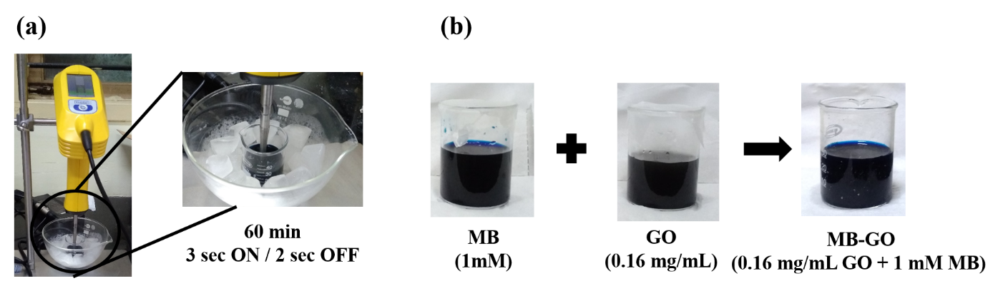

**Fig. S1.** (**a**) Photographs of MB-GO dispersed aqueous solution by probe sonicator and (**b**) pristine MB, GO and MB-GO in aqueous solution.



**Fig. S2:** Interaction profile of *h*ACE-2 N-terminal peptide and interferents. Binding profile of *h*ACE-2 N-terminal peptide (cyan) and interferents (green and orange {interacting amino acid residues}). (A) Lactoferrin. (B) Human Serum Albumin (HSA). (C) Non-structural Protein 1, Dengue virus (NS1). (D) Immunoglobulin (IgG).



**Fig. S3.** Interaction profile of *h*ACE-2 N-terminal peptide and mutated SARS-CoV-2 spike protein.Binding profile of *h*ACE-2 N-terminal peptide (cyan) and mutated spike proteins, (green & orange {interacting amino acid residues}) A) G614, B) B.1.17, C) B.1.1.28, D) B.1.427/429, E) B.1.1.318, F) B.1.375, G) B.1.1.28.2, H) B.1.525, I) B.1.526, J) A.23.1, K) B.1.177, L) B.1.616, M) B.1.617, N) N440K.



**Fig. S4.** FE-SEM image of (**A**) pristine GO and (B) MB-GO modified electrode substrate at 25 K× magnification. Scale bar: 2 µm. EDS of (C) pristine GO and (D) MB-GO.

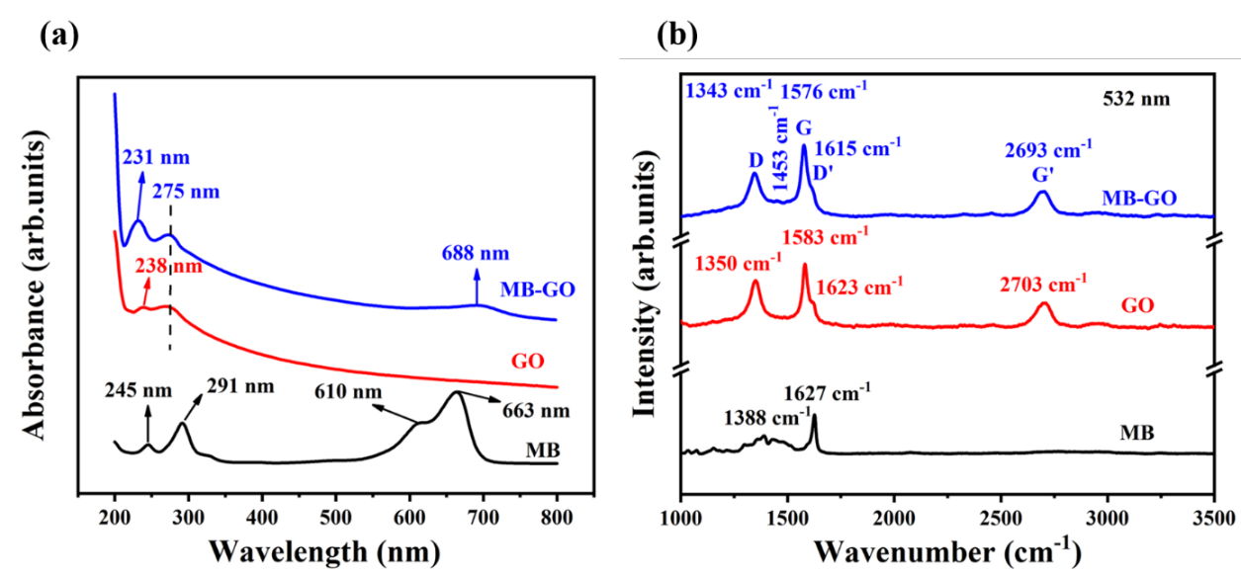

**Fig. S5.** (**a**) UV-visible and (**b**) Raman spectra (at laser excitation wavelength 532 nm) of MB (black), GO (red) and MB-GO (blue).

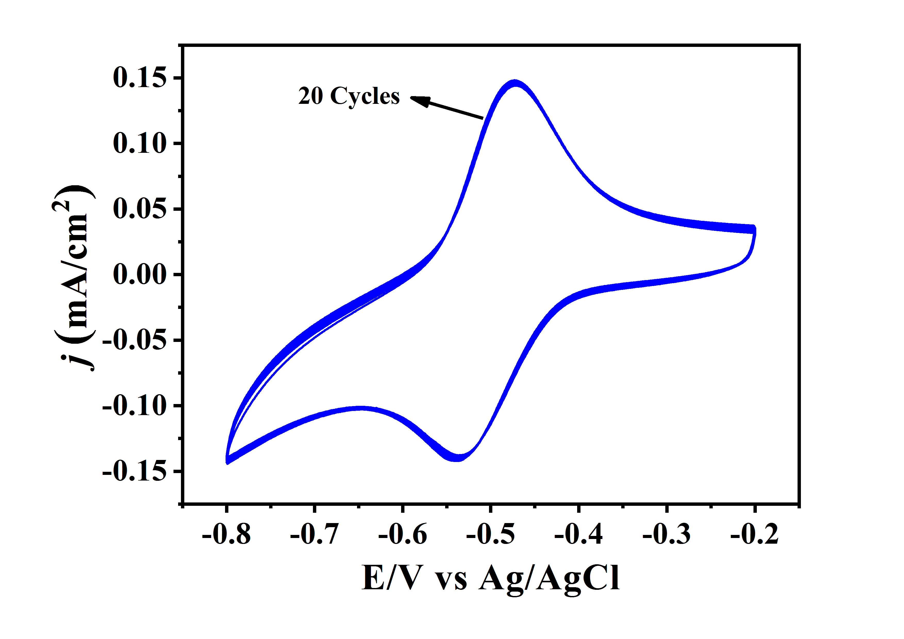

**Fig. S6.** Repetitive CVs of MB-GO/SPE in 0.1 M PBS (pH 7.4) at a scan rate of 50 mV/s. Total number of CV cycles are 20.

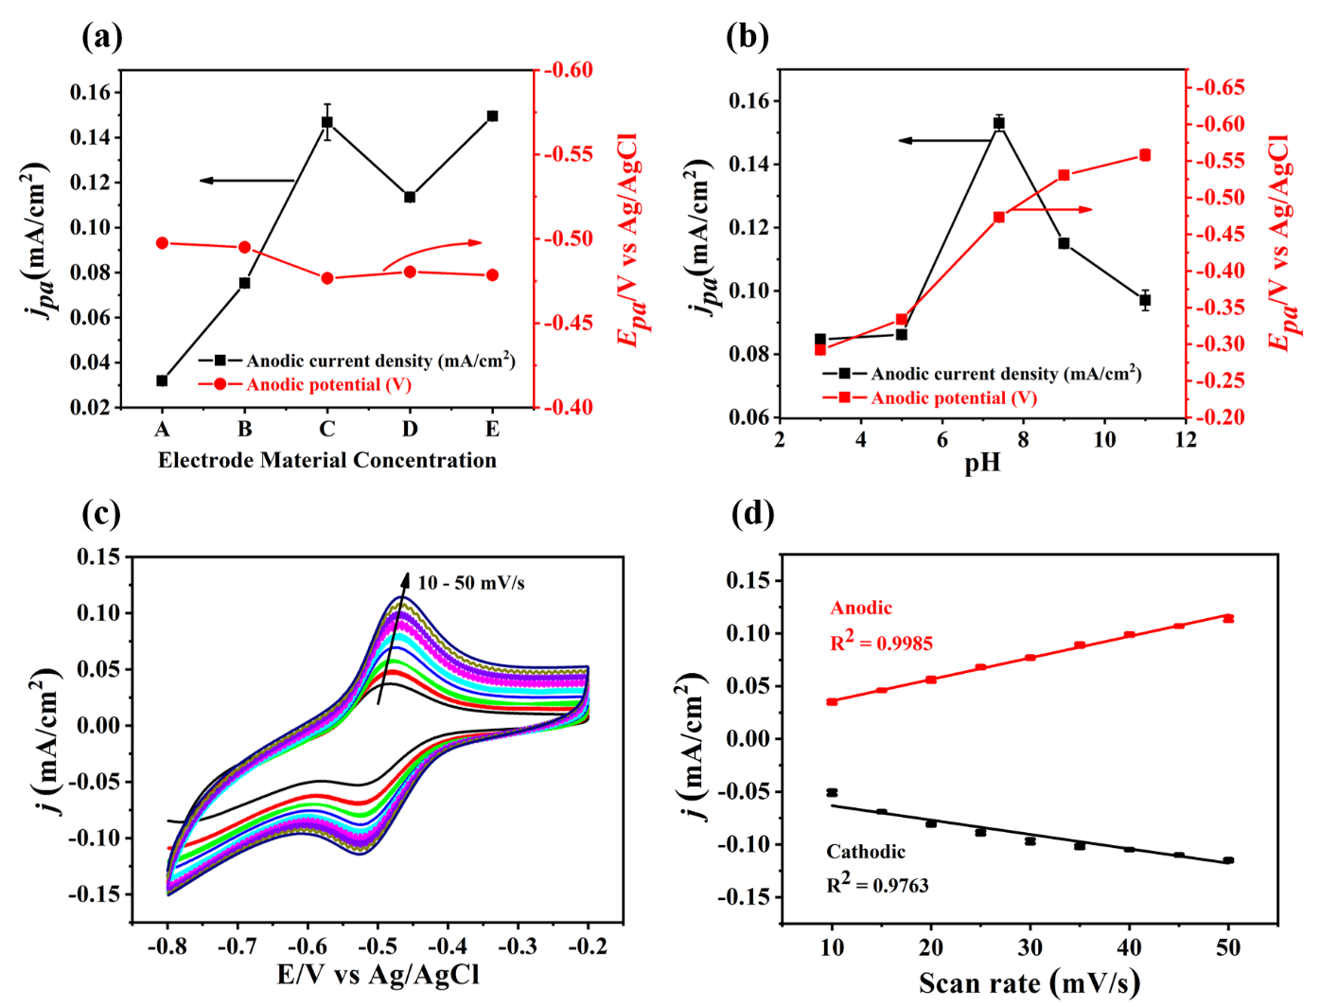

**Fig. S7.** (**a**) The effect of MB-GO concentration (A to E) on anodic current density (*jpa*) with anodic potential (*Epa*) in 0.1 M PBS (pH 7.4) at a scan rate of 50 mV/s (n=3). The catalyst concentration details: A = 0.016 mg/mL (GO) in 0.1 mM (MB), B = 0.08 mg/mL (GO) in 0.5 mM (MB), C = 0.16 mg/mL (GO) in 1 mM (MB), D = 0.25 mg/mL (GO) in 1 mM (MB), 0.5 mg/mL (GO) in 2 mM (MB). (**b**) The effects of pH conditions (3 to 11) on anodic current density (*jpa*) with anodic potential (*Epa*) in 0.1 M PBS (pH 7.4) at a scan rate of 50 mV/s (n=3). (**c**) CVs of MB-GO/SPE at different scan rates (10 – 50 mV/s) in 0.1 M PBS (pH 7.4). (**d**) The plots of scan rates versus anodic and cathodic current density (*n*=3).



**Fig. S8** CVs of prepared sensor platform with different immobilization layer such as bio-affinity material (*b*), scrambled *h*ACE-2 N-terminal peptide (S-NP), bovine serum albumin (BSA as blocking agent), active *h*ACE-2 peptide sequence (NP) and target spike protein (SP). Analyte SP concentration 10 ng/mL.

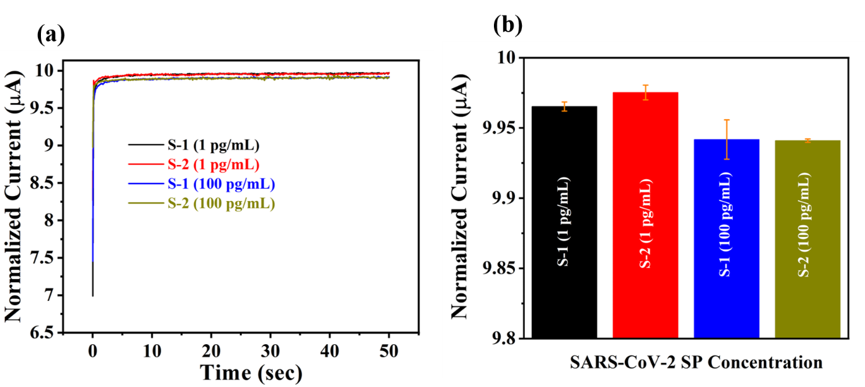

**Fig. S9.** (**a**) Chronoamperometric sensing performance of prepared peptide-based sensor platform with two different gargled lavage (S-1 and S-2) spiked with SP sample concentration. (**b**) Histogram depicting the corresponding amperometric quenching response against two different SP concentration.



**Fig. S10.** (A)Chronoamperometric sensing performance of prepared peptide-based sensor platform with different gargled lavage SP sample concentration such as S3: 20, S4: 40, S5: 60, S6: 80, S7: 100 and S8: 120 ng/mL. (B) Histogram depicting the corresponding amperometric quenching response against different SP concentration.

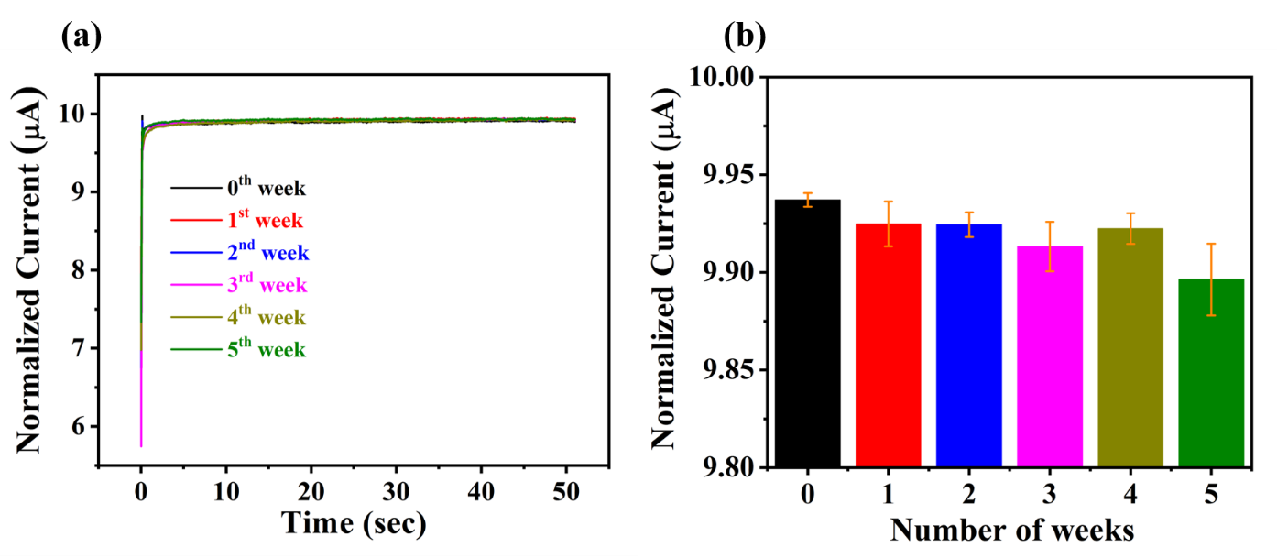

**Fig. S11.** (**a**) Chronoamperometric response of BSA/NP/*b*/MB-GO/SPE electrode against SARS-CoV-2 SP (100 pg/mL) recorded in various time interval. (**b**) Chronoamperometric histogram from BSA/NP/*b*/MB-GO/SPE electrode for stability studies (n=3) and its %RSD for 0, 1, 2, 3, 4 and 5 weeks was calculated to be 0.03, 0.11, 0.06, 0.12, 0.07 and 0.18%, respectively.

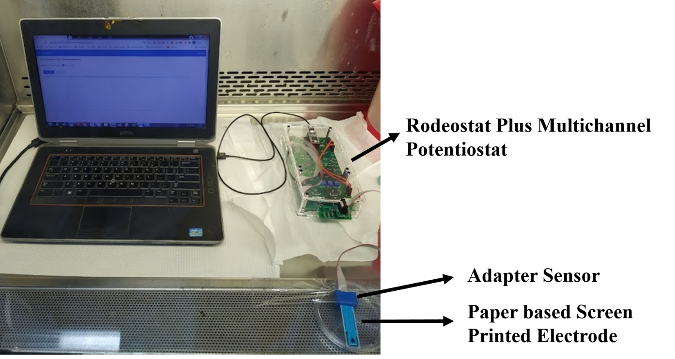

**Fig. S12.** The SARS-CoV-2 SP detection setup for electrochemical analysis by using a portable potentiostat device connected to a laptop.

**Table S1. Interaction profiles of *h*ACE-2 peptides and SARS CoV-2 spike protein (PDB id: 6VYB).**

|  |  |  |  |  |
| --- | --- | --- | --- | --- |
| **Peptides of *h*ACE-2** | ***h*ACE-2 peptide residues** | **SARS CoV-2 spike protein** | **H- bond length (Å)** | **Amino acid residues in the hydrophobic pocket** |
| N-Terminal | Gln 24 | Thr 500 | 2.97 | Tyr 505, Gly 504, Asn 501, Gly 496,Tyr 495, Pro 491, Tyr 493, Phe 490, Gln 455, Phe 456, Ser 459, Lys 455 |
| Lys 13 | Ser 494 | 2.93 |
| Glu 19 | Arg 403 | 2.92 |
| Asp 12 | Lys 417 | 3.55 |
| Thr 2 | Arg 457 | 2.75, 3.04, 2.69 |
| Ser 1 | 2.91, 2.33 |
| Tyr 421 | 3.21 |
| C-Terminal | Glu 17 | Lys 417 | 3.14 | Pro 499, Gln 496, thr 500, Tyr 505, Val 503, Asn 501, Leu 455, Gly 496, Tyr 453, Tyr 495, Tyr 449 |
| Arg 403 | 2.56 |
| Ile 23 | Ser 494 | 3.22 |
| Asp 24 | Gln 493 | 2.90 |
| Ile 25 | Ser 494 | 2.83 |

**Table S2. Interaction profiles of Interferents with *h*ACE-2 N-terminal peptide.**

|  |  |  |  |
| --- | --- | --- | --- |
| **N-terminal peptide of *h*ACE-2** | **Interferents** | **H- bond length (Å)** | **Amino acid residues in the hydrophobic pocket** |
|  | **Lactoferrin** |  | Thr 370, Leu 383, ser 253, Glu 336, Cys 371, Phe 325, Val 260, Arg 344, Tyr 65, Ala 340, Arg 341, Tyr 372, Leu 369, Arg 258 |
| Lys 13 | Lys 329 | 2.69 |
| Asp 20 | Lys 386 | 2.33 |
| Glu 19 | Ala 70 | 3.37 |
| Tyr 23 | Lys 73 | 3.50 |
| Ser 25 | Lys 73 | 3.88 |
| Asp 12 | Lys 333 | 3.35 |
| Gln 6 | Gly 367 | 3.82 |
| Thr 9 | Glu 337 | 2.69 |
|  | **HSA** |  | Phe 395, Ser 435, His 440, Cys 448, Lys 432, Tyr 452, Pro 447, Glu 400, Val 293, Glu 294, Arg 218, Glu 292, Ala 291, Leu 395, Tyr 401, Gly 399 |
| Lys 13 | Asp 187 | 2.69 |
| Gln 6 | Lys 522 | 2.63 |
| Asn 15 | Lys 439 | 3.21 |
| Lys 436 | 2.73 |
| Gln 17 | 2.83 |
| Glu 19 | Lys 444 | 3.08 |
| Leu 21 | Lys 195 | 3.03 |
| Tyr 23 | 3.06 |
| Asn 295 | 2.93 |
| Ser 25 | His 242 | 2.83 |
| Arg 222 | 3.27 |
| Lys 199 | 2.35 |
| Gln 24 | Arg 222 | 3.31 |
| Ser 1 | Lys 402 | 2.93 |
| Glu 4 | 2.96 |
|  | **NS1** |  | Tyr 153, Phe 160, Tyr 32, Asp 28, His 26, Thr 22, Ile 18, Thr 27, Val 8, Val 155, Glu 154, Glu 156 |
| Glu 17 | Gly 161 | 2.59 |
| Glu 4 | Ser 181 | 2.76 |
| Ser 25 | Gln 31 | 2.89 |
| Trp 28 | 2.32 |
| The 29 | 2.51 |
| Gln 24 | 2.74 |
| Asn 15 | Phe 20 | 2.52 |
| Ile 3 | Lys 182 | 2.98 |
| Thr 2 | Lys 170 | 2.97 |
| Gln 6 | Asp 157 | 2.51 |
| Asp 12 | Asp 1 | 2.80 |
|  | **Immunoglobin G** |  |  |
| **H- chain** | | | Pro 423, Val 425, Leu 426, Asp 427, Ser 428 |
| Tyr 23 | Pro 424 | 2.77 |
| **K- chain** | | | Phe 236, Lys 335, Asp 399, Trp 332, Gly 361, Pro 260, Pro 424, Ala 339, Pro 423, Tyr 366, Phe 433, Ser 395, Lys 426, Thr 421, Ile 333, Pro 237 |
| Gln 6 | Ser 357 | 2.54 |
| Lys 13 | Leu 255 | 3.01 |
| Glu 5 | Lys 360 | 3.32 |

**Table S3**. **Interaction profiles of *h*ACE-2 peptide with mutated spike proteins.**

|  |  |  |  |
| --- | --- | --- | --- |
| **N-terminal peptide of *h*ACE-2** | **Mutant Spike protein** | **H- bond length (Å)** | **Amino acid residues in the hydrophobic pocket** |
| **G614** | | | |
| Tyr 23 | Gln 404 | 2.70 | Gly 416, Thr 415, Tyr 505, Asp 501, Tyr 495, Leu 455, Asp 403, Tyr 453 |
| Asp 20 | 3.14 |
| Asp 20 | Arg 408 | 2.73 |
| 2.79 |
| Ser 25 | 2.60 |
| Lys 13 | Arg 403 | 2.37 |
| Gly 496 | 2.76 |
| Gln 6 | Tyr 449 | 3.79 |
| Thr 9 | Ser 494 | 2.36 |
| Lys 8 | Gln 493 | 2.63 |
| **B.1.1.7** | | | |
| Asp 20 | Lys 417 | 3.06 | Gln 493, Tyr 489, Leu 455, Phe 456, Ala 475, Gln 477, Lys 458, Gly 476, Pro 479, Ile 472, Gly 482, Cys 480,  Gln 471 |
| Gln 24 | Tyr 453 | 2.72 |
| Tyr 23 | Arg 403 | 2.94 |
| Lys 13 | Tyr 421 | 2.91 |
| Arg 457 | 3.00 |
| Asp 12 | Tyr 473 | 3.22 |
| Lys 3 | Asn 481 | 2.82 |
| Thr 2 | 2.46 |
| **B.1.1.28** | | | |
| Lys 13 | Lue 492 | 2.67 | Gln 493, Phe 496, Lys 449, Tyr 489, Leu 452, Gly 485 |
| Thr 9 | Tyr 449 | 2.96 |
| Gln 6 | Gly 447 | 2.67 |
| Thr 2 | Asn 450 | 2.72 |
| Glu 19 | Lys 484 | 2.72 |
| Asp 12 | 2.63 |
| **B.1.429/427** | | | |
| Glu 17 | Lys 417 | 2.78 | Tyr 449, Ser 494, Gln 493, Tyr 505, Asn 501, Phe 497, Gly 496, Glu 406, Tyr 453, Val 407, Val 503, Asp 405, Leu 455, Gly 404, Gly 504 |
| Glu 19 | Tyr 495 | 3.00 |
| Asp 20 | Arg 403 | 2.78 |
| 2.00 |
| Gln 409 | 2.70 |
| Gln 24 | Arg 408 | 3.18 |
| 2.70 |
| Ser 25 | The 376 | 2.90 |
| **B.1.1.318** | | | |
| Lys 13 | Tyr 505 | 3.14 | Asp 405, val 503, Tyr 449, Phe 490, Tyr 495, Gln 493, Leu 455, Leu 452 |
| Glu 19 | Gly 504 | 2.39 |
| Gln 24 | Asn 501 | 2.54 |
| Asp 12 | Tyr 453 | 3.33 |
| Thr 9 | Tyr 496 | 3.04 |
| Ser 494 | 2.93 |
| **B.1.375** | | | |
| Asp 20 | The 500 | 2.55 | Pro 499, Asn 501,Gln 498, Gln 508, Gly 496, Phe 497, Tyr 495, Tyr 453, Pro 49, Phe 456, ser 494 |
| Glu 19 | Val 503 | 2.68 |
| Gly 504 | 2.89 |
| Asn 15 | Arg 403 | 2.63 |
| His 16 | Tyr 505 | 3.11 |
| Ser 1 | Gln 493 | 2.73 |
| Lys 8 | Leu 455 | 3.09 |
| Glu 5 | Phe 490 | 2.34 |
| **B.1.1.28.2** | | | |
| Asp 20 | Lys 417 | 2.91 | Tyr 449, Leu 455, Tyr 495, Ser 494, Tyr 453, Phe 490, Tyr 505, Gly 504, Leu 452 |
| Gln 24 | Gln 493 | 2.29 |
| His 16 | Lys 417 | 2.87 |
| Thr 9 | Val 203 | 2.81 |
| Asp 12 | Arg 403 | 2.16 |
| 3.01 |
| Lys 8 | Asn 501 | 2.65 |
| Glu 4 | Thr 500 | 2.47 |
| **B.1.525** | | | |
| Asp 20 | Tyr 505 | 2.82 | Val 503, Gly 504, Gln 506, Asn 501, Thr 500, Gly 496, Phe 490, Leu 455, Tyr 453, Gln 493, Leu 452, Leu 492 |
| Lys 13 | Leu 492 | 2.40 |
| Glu 4 | Ser 494 | 2.93 |
| 2.57 |
| Thr 2 | 3.29 |
| Tyr 449 | 2.67 |
| 2.82 |
| Ser 1 | Asn 450 | 2.65 |
| Tyr 449 | 2.98 |
| **B.1.526** | | | |
| Asp 12 | Lys 417 | 2.82 | Gly 496, Gln 409, Ser 494, Tyr 505, Leu 455, Tyr 453, Arg 403, Tyr 495, Val 503, Gly 504, Asp 405, Gly 404, Val 407, Ser 375, Tyr 449 |
| Glu 5 | Arg 408 | 2.68 |
| Tyr 23 | Gln 493 | 2.01 |
| Thr 2 | Tyr 508 | 2.38 |
| **B.1.177** | | | |
| Tyr 23 | Thr 500 | 2.58 | Asn 501, Leu 452, Tyr 449, Asp 425, Phe 456, Phe 490, Leu 455 |
| Glu 17 | Gly 504 | 2.80 |
| Val 503 | 2.63 |
| Asp 20 | 2.89 |
| Tyr 505 | 2.71 |
| Gln 24 | Gly 496 | 3.11 |
| Lys 13 | 2.73 |
| Thr 9 | Tyr 453 | 3.07 |
| Ser 494 | 2.26 |
| His 16 | Arg 403 | 3.09 |
| Asp 12 | 3.03 |
| Lys 417 | 2.47 |
| Glu 5 | Gln 493 | 2.66 |
| Gln 6 | 3.14 |
| 2.72 |
| **A.23.1** | | | |
| Ala 7 | Arg 403 | 2.53 | Gln 493, Asp 405, Lys 417, Ser 494, Leu 492, Gly 404, Phe 490, Leu 452, Leu 455, Tyr 505, Val 502, Asn 501 |
| Asn 15 | Tyr 453 | 2.27 |
| Gln 6 | Gly 504 | 2.75 |
| Lys 13 | Gly 496 | 2.59 |
| Glu 17 | Tyr 449 | 2.78 |
| **B.1.616** | | | |
| Asp 12 | Lys 417 | 3.10 | Gly 504, Tyr 505, Gly 496, Asp 405, Phe 497, Tyr 495, Gln 409, Thr 415, Glu 406, Arg 408, Tyr 449, Phe 490 |
| Glu 19 | 2.99 |
| Asp 20 | 2.73 |
| Glu 17 | Arg 403 | 2.72 |
| Lys 13 | 2.97 |
| Thr 9 | Ser 494 | 2.46 |
| Tyr 453 | 2.71 |
| Glu 5 | Gln 493 | 3.69 |
| **B.1.617** | | | |
| Asp 20 | Tyr 421 | 2.75 | Val 503, Pro 491, Asn 501, Arg 457, Phe 456, Phe 490, Thr 415, Gly 504, Tyr 505, Lys 458, Leu 455, Gly 416, Tyr 495, Asp 405, Ile 418, Glu 406 |
| Glu 19 | Lys 417 | 2.66 |
| His 16 | 2.99 |
| Arg 403 | 3.25 |
| Gln 409 | 3.25 |
| Glu 17 | 2.50 |
| Arg 408 | 2.25 |
| **N440K** | | | |
| Asn 15 | Lys 417 | 2.60 | Gln 498, tyr 449, Gly 416, Gly 496, Phe 456, Ile 418, Tyr 453, Gln 493, Ser 494, Leu 455, Asp 405, Arg 408 |
| Asp 20 | Arg 403 | 2.59 |
| 2.89 |
| Glu 19 | 2.69 |

**Table S4.** %RSD for the determination of SARS-CoV-2 SP protein concentrations using BSA/NP/*b*/MB-GO/SPE electrode with different analytical techniques.

|  |  |  |
| --- | --- | --- |
| **Concentration of SP (ng/mL) in PBS** | **Cyclic Voltammetry (%RSD)** | **Chronoamperometry**  **(%RSD)** |
| 0.001 | 4.6 | 0.07 |
| 0.01 | 5.5 | 0.16 |
| 0.1 | 3.5 | 0.07 |
| 1 | 3.0 | 0.04 |
| 10 | 3.5 | 0.08 |
| 100 | 2.3 | 0.12 |
| 1000 | 6.1 | 0.14 |

**Table S5**. Analytical comparison of this proposed electrochemical biosensor performance against other test kits and current biosensors for SARS-CoV-2.

|  |  |  |  |  |  |
| --- | --- | --- | --- | --- | --- |
| **Analytical Strategy** | **Assay time** | **Technique** | **Detection Range** | **Target and LOD** | **Reference** |
| NAQ strategy based on C2CA and optomagnetic analysis | 100 min | Optomagnetic | 0.1 to 1000 fM | RdRp: 0.4 fM | [6] |
| CRISPR technology | 1 h | Fluorescence | 1 × 10-7 to  1 × 10-2 M | S, N and Orf1ab genes: 42 copies/reaction | [7] |
| DNHCR-based nucleic acid assay | 10 min | Fluorescence | 0 to 100 nM | conserved region:  0.96 pM | [8] |
| 4WJ-based electrochemical biosensor | 40 min | SWV | 1 × 10-16 M to  1 × 10-11 M | S = 5 ag/μL  ORF1ab = 6.8 ag/μL | [9] |
| Electrochemical biosensor | < 20 min | DPV | 1 × 103 to  1 × 109 copies/µL | RdRP gene: 0.972 fg/μL  N gene: 3.925 fg/μL | [10] |
| Electrochemical RNA biosensor | - | DPV | 1 × 10-17 to  1 × 10-12 M | ORF1ab: 200 copies/ml | [11] |
| RCA (nucleic acid) based electrochemical biosensor | <2 h | DPV | 1 to 1 × 1010 copies/µL | N and S genes: 1 copy/ µL | [12] |
| Electrochemical immunoassay | ~ 35 min | SWV | 1 ag/mL to 10 fg/mL | S gene: 1 ag/mL | [13] |
| Oligopeptide-based  electrochemical biosensor | ~20 min | CV and CA | 1 pg/mL to  1 µg/mL | S protein: 0.58 pg/mL (CV) and 0.71 pg/mL (CA) | This work |

NAQ: nucleic acid quantification, C2CA: Circle-to circle amplification, RdRp: RNA-dependent RNA polymerase, CRISPR: clustered regularly interspaced short palindromic repeats, Orf1ab: overlapping open reading frame, S: spike, N: nucleocapsid, DNHCR: DNA nano scaffold hybrid chain reaction, RCA: rolling circle amplification, 4WJ: Four-way junction, SWV: square wave voltammetry, DPV: differential pulse voltammetry.

**Table S6.** %RSD for the cyclic voltammetric and chronoamperometric response measured from the BSA/NP/*b*/MB-GO/SPE electrode against target, interferants and mixture of target and interferents.

|  |  |  |  |
| --- | --- | --- | --- |
| **Analyte** | **Analyte Concentration (ng/mL) in PBS** | **Cyclic Voltammetry**  **(% RSD)** | **Chronoamperometry**  **(% RSD)** |
| SP-I | 0.001 | 1.7 | 0.04 |
| NS-I | 0.1 | 1.2 | 0.12 |
| HSA-I | 0.1 | 0.9 | 0.1 |
| IgG-I | 0.1 | 1.3 | 0.1 |
| SP-II | 0.1 | 4.7 | 0.12 |
| SP-II+NS1-II | 0.1:100 | 1.7 | 0.16 |
| SP-II+HSA-II | 0.1:100 | 3.0 | 0.4 |
| SP-II+IgG-II | 0.1:100 | 2.0 | 0.08 |

**Table S7.** Chronoamperometric response of BSA/NP/*b*/MB-GO/SPE electrode against two different viral loads (SARS-CoV-2) in comparison with RT-PCR kit-based ORF and E Gene cycle threshold value (CT).

|  |  |  |  |  |
| --- | --- | --- | --- | --- |
| **Sample ID** | **ORF CT**  **by**  **RT-PCR** | **E Gene CT**  **by**  **RT-PCR** | **SP Found**  **(pg/mL)** | **Result** |
| VTM | - | - | - | - |
| LC-19 | 34 | 34 | 0.99 | Positive |
| HC-19 | 14 | 15 | 99.97 | Positive |

**Table S8. The recovery of SARS-CoV-2 SP protein in spiked human control swab samples for the validation of chronoamperometric SP sensing.**

|  |  |  |  |  |
| --- | --- | --- | --- | --- |
| **Control Swab Samples** | **Spiked SP (pg/mL)** | **Chronoamperometry** | | |
|  |  | **SP Found**  **(pg/mL)** | **SP Recovery**  **(%)** | **SP (%RSD)**  **(*n*=3)** |
| S-1 | 1  100 | 0.99  99.96 | 99.8  99.9 | 0.03  0.14 |
| S-2 | 1  100 | 0.99  99.95 | 99.9  99.9 | 0.05  0.18 |

**References**

[1] J.Y. Lee, S.H. Lee, H.M. Lee, S.H. Lee, H.H. Jung, S.W. Lee, S.M. Kang, Analysis of gene expression profiles of normal human nasal mucosa and nasal polyp tissues by SAGE, Journal of Allergy and Clinical Immunology. 118 (2006) 134–142. https://doi.org/10.1016/J.JACI.2006.02.048.

[2] R.M. Torrente-Rodríguez, H. Lukas, J. Tu, J. Min, Y. Yang, C. Xu, H.B. Rossiter, W. Gao, SARS-CoV-2 RapidPlex: A Graphene-Based Multiplexed Telemedicine Platform for Rapid and Low-Cost COVID-19 Diagnosis and Monitoring, Matter. 3 (2020) 1981–1998. https://doi.org/10.1016/j.matt.2020.09.027.

[3] M. Veerapandian, R. Hunter, S. Neethirajan, Dual immunosensor based on methylene blue-electroadsorbed graphene oxide for rapid detection of the influenza A virus antigen, Talanta. 155 (2016) 250–257. https://doi.org/10.1016/j.talanta.2016.04.047.

[4] P. Kanagavalli, M. Veerapandian, Opto-electrochemical functionality of Ru(II)-reinforced graphene oxide nanosheets for immunosensing of dengue virus non-structural 1 protein, Biosensors and Bioelectronics. 150 (2020) 111878. https://doi.org/10.1016/j.bios.2019.111878.

[5] Y. Badhe, R. Gupta, B. Rai, In silico design of peptides with binding to the receptor binding domain (RBD) of the SARS-CoV-2 and their utility in bio-sensor development for SARS-CoV-2 detection, RSC Advances. 11 (2021) 3816–3826. https://doi.org/10.1039/D0RA09123E.

[6] B. Tian, F. Gao, J. Fock, M. Dufva, M.F. Hansen, Homogeneous circle-to-circle amplification for real-time optomagnetic detection of SARS-CoV-2 RdRp coding sequence, Biosensors and Bioelectronics. 165 (2020) 112356. https://doi.org/10.1016/j.bios.2020.112356.

[7] M. Patchsung, K. Jantarug, A. Pattama, K. Aphicho, S. Suraritdechachai, P. Meesawat, K. Sappakhaw, N. Leelahakorn, T. Ruenkam, T. Wongsatit, N. Athipanyasilp, B. Eiamthong, B. Lakkanasirorat, T. Phoodokmai, N. Niljianskul, D. Pakotiprapha, S. Chanarat, A. Homchan, R. Tinikul, P. Kamutira, K. Phiwkaow, S. Soithongcharoen, C. Kantiwiriyawanitch, V. Pongsupasa, D. Trisrivirat, J. Jaroensuk, T. Wongnate, S. Maenpuen, P. Chaiyen, S. Kamnerdnakta, J. Swangsri, S. Chuthapisith, Y. Sirivatanauksorn, C. Chaimayo, R. Sutthent, W. Kantakamalakul, J. Joung, A. Ladha, X. Jin, J.S. Gootenberg, O.O. Abudayyeh, F. Zhang, N. Horthongkham, C. Uttamapinant, Clinical validation of a Cas13-based assay for the detection of SARS-CoV-2 RNA, Nature Biomedical Engineering. 4 (2020) 1140–1149. https://doi.org/10.1038/s41551-020-00603-x.

[8] J. Jiao, C. Duan, L. Xue, Y. Liu, W. Sun, Y. Xiang, DNA nanoscaffold-based SARS-CoV-2 detection for COVID-19 diagnosis, Biosens Bioelectron. 167 (2020) 112479. https://doi.org/10.1016/j.bios.2020.112479.

[9] L. Kashefi-Kheyrabadi, H.V. Nguyen, A. Go, C. Baek, N. Jang, J.M. Lee, N.-H. Cho, J. Min, M.-H. Lee, Rapid, multiplexed, and nucleic acid amplification-free detection of SARS-CoV-2 RNA using an electrochemical biosensor, Biosensors and Bioelectronics. 195 (2022) 113649. https://doi.org/10.1016/j.bios.2021.113649.

[10] H.E. Kim, A. Schuck, S.H. Lee, Y. Lee, M. Kang, Y.-S. Kim, Sensitive electrochemical biosensor combined with isothermal amplification for point-of-care COVID-19 tests, Biosensors and Bioelectronics. 182 (2021) 113168. https://doi.org/10.1016/j.bios.2021.113168.

[11] H. Zhao, F. Liu, W. Xie, T.-C. Zhou, J. OuYang, L. Jin, H. Li, C.-Y. Zhao, L. Zhang, J. Wei, Y.-P. Zhang, C.-P. Li, Ultrasensitive supersandwich-type electrochemical sensor for SARS-CoV-2 from the infected COVID-19 patients using a smartphone, Sens Actuators B Chem. 327 (2021) 128899. https://doi.org/10.1016/j.snb.2020.128899.

[12] T. Chaibun, J. Puenpa, T. Ngamdee, N. Boonapatcharoen, P. Athamanolap, A.P. O’Mullane, S. Vongpunsawad, Y. Poovorawan, S.Y. Lee, B. Lertanantawong, Rapid electrochemical detection of coronavirus SARS-CoV-2, Nat Commun. 12 (2021) 802. https://doi.org/10.1038/s41467-021-21121-7.

[13] L. Liv, G. Çoban, N. Nakiboğlu, T. Kocagöz, A rapid, ultrasensitive voltammetric biosensor for determining SARS-CoV-2 spike protein in real samples, Biosensors and Bioelectronics. 192 (2021) 113497. https://doi.org/10.1016/j.bios.2021.113497.